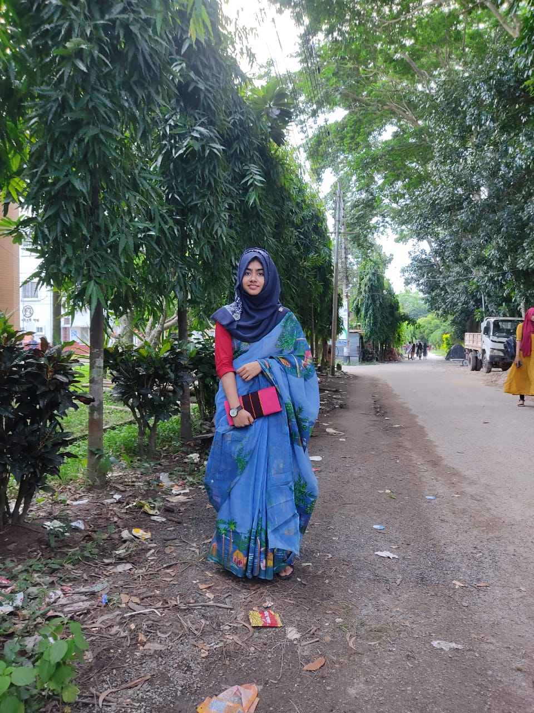

* SSC, 2018,Jahangirnagar University School and College,GPA-5.00
* HSC, 2020,Jahangirnagar University School and College,GPA-5.00
* BSC in Agriculture (Hons.), Patuakhali Science and Technology University

**EXPERIENCES**

General member of BADHAN,PSTU

Participation at NACO, IAAS BANGLADESH

* Father’s Name: Md. Merazul Haq; Retired Officer of BKB
* Mother’s Name: Mst. Mamtaz Begum; Housewife
* Address: Ambagan, Savar, Dhaka
* Siblings: Abdullah Al Moktadir,Abdullah Al Mossabbir
* Religion: Islam
* Date of Birth: 11th July,2002

**EDUCATION**

**SUMMARY**

* Gardening
* Traveling
* Crafting

**HOBBIES**

* Bangla
* English

**LANGUAGES**

Savar , Dhaka

01886280368

[marziamomo20@gmail.com](mailto:marziamomo20@gmail.com)

MS. MARZIA MOMO